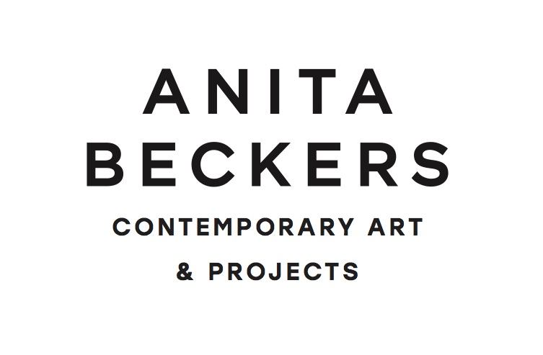
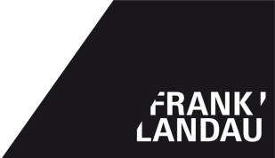

Favorites III
Drawing & Design

Lena Ditlmann combines her works with objects from the collection Frank Landau

Vernissage: September 6, 2017 from 7 – 9 pm
Duration of exhibition: September 7 – October 7, 2017

Opening speech: Prof. Dr. Christian Janecke, University of Art and Design, Offenbach

For the two year anniversary of the cooperation between Anita Beckers and Frank Landau and on the occasion of the Season Start of the Frankfurt galleries, will we show the third collective exhibition „FAVORITES III. Drawing & Design.“

The Frankfurt- based artist, Lena Ditlmann, will exhibit new drawings in dialogue with material she has chosen from the collection Frank Landau.

The abstract motifs of the drawings by Lena Ditlmann are comprised of fine lines that are tangled up with one another on the paper. They are reminiscent of nature. Lena Ditlmann’s focus, however, does not lie in the visual imitation of organic structures and forms. Instead, the artist is more interested in the systematic construction of natural elements. This recalls mathematical properties that have fascinated people of since ancient times and are understood as the primary structures of the world. By using these properties as a design medium, Lena Ditlmann constructs shapes that oscillate between the visible/objective and the invisible/subjective world.

The carefully chosen works from the collection Frank Landau are mostly from the 20th century. Among others, a head ornament made of painted wicker, a photograph from Karl Blossfeldt and a bowl by Tapio Wirkkala will be exhibited. The artists from an applied-art background’s research and experimentation with form and content have remained prevalent regardless of the time in which they were conceived. Lena Ditlmann picked objects whose properties reflect natural qualities. Thereby, they are not only exhibition pieces but also strengthen the design basis of her own work.

Lena Ditlmann is a graduate of the University of Art and Design, Offenbach. As well, she studied under Judith Hopf for two years at the Frankfurt Städel School.

Opening times during the Season Start:
September 8th, 6 – 10 pm I September 9th, 11 – 6 pm I September 10th, 11 – 6 pm

