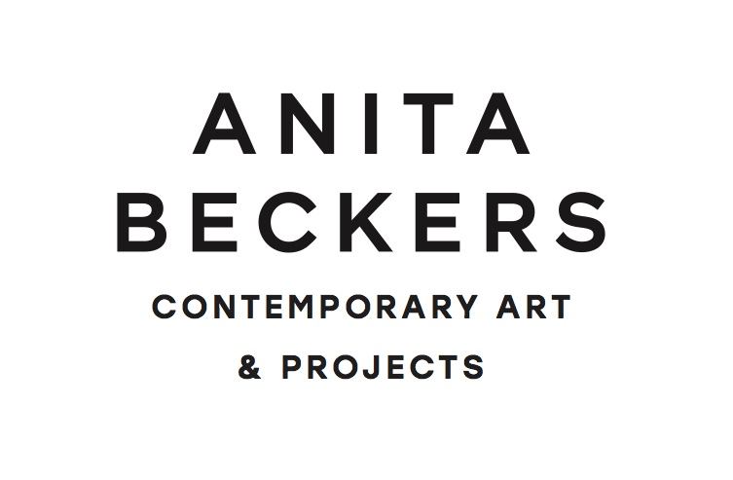
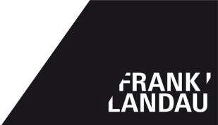

FAVORITES II – for sale

Galerie Beckers / Landau
Braubachstrasse 9
60311 Frankfurt am Main

E-Mail: info@galerie-beckers.de / info@franklandau.com
Tel.: 069 921 01 972

Opening times: Tu – Fr 12 – 6:30pm / Sa 12 – 5pm
and by appointment

We are delighted to invite you tot he one year anniversary of our gallery cooperation.

Independent of the succesful opening exhibtion „FAVORITES – not for sale,“ we would like to thank all collectors and friends of the gallery Beckers/Landau that have accompanied our alternating dialogue between art and design. For the exhibition „FAVORITES II – for sale,“ we have chosen works from the past few decades from artists and designers considered important protagonists of their time, as well as, up-and-coming positions developed based upon the hertiage of art history.
This exciting juxtaposition simultaneously underlines the challenge that both gallerists, through their continuous scrutinization and interaction with art and design, undertook.

Highlight of the exhibition FAVORITES II
During the examination of art from the 60ies, including ZERO, the gallery came across a spectacular find that we would like to present at the Season Opening.

While dissolving Otto Piene's Studio in Düsseldorf, his widow found "Supergouachen" - or so Piene called the works. The works had been forgotten for 40 years. A tape recording from an interview with Piene proves without a doubt that these works were created from the middle of the 70ies to the 80ies. Certificates from Elizabeth Goldring Piene confirm the authenticity of the works. One of the fours works is signed and titled. Often, Piene would only sign a work after it was sold, a typical practice at the time.

Selection of presented positions: Jürgen Klauke, Christiane Feser, Lena Ditlmann, Hermann Göpfert, Otto Piene, Carlo Hauner & Martin Eisler, Tommi Parzinger, Yngve Ekström, Vittorio Nobili, Angelo Lelli, Preben Fabricius & Jorgen Kastholm, Martin Schlotz.

